Computer Science 220L
Laboratory 3 –Arithmetic, Loops
Learning Objectives:
- Develop simple Python programs that do input, produce output and do arithmetic using loops.
- Develop simple Python programs that use for loops.

Directed Activities:
0. Download lab3.py. Demonstrate each of your solutions for the instructor.

- Sum of squares.
Write a function sumSquares() that calculates the sum of the squares of the numbers in a given range. The function should allow the user to input the starting and ending numbers within the range. For example if the user inputs 3 as the lower range and 5 as the upper range, the function should return the result of the equation 3²+4²+5² which is 50.

- Manually finding the power.
Sadly, Phil the philosopher has found himself stranded on a deserted island with a bad version of Python that does not support the ** operator nor the math library function math.pow(). Phil needs to be able to calculate the power of numbers. Write a function for him called power() that asks the user to input a base and an exponent. The function should use a loop to calculate and output the power.

- Fibonacci.
A Fibonacci sequence is a sequence of numbers where each successive number is the sum of the previous two. The classic Fibonacci sequence begins: 0, 1, 1, 2, 3, 5, 8, 13, …. Write a function, fibonacci() , that computes and outputs all of the Fibonacci numbers up to and including the nth number, where n is a value input by the user.

- Compute a square root. (Adapted from the text, p. 78, Exercise 17)
Write a function newton() that approximates the square root of a number using Sir Isaac Newton's method. Ask the user what the number, x, is and how many times to improve the approximation. x / 2 is a good first approximation. Given an existing approximation,
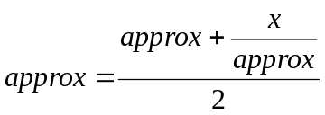

is a better approximation. Display the number and the final value of the approximation.

- Computing pi.
Write a function pi() that approximates the value of using the Wallis formula:
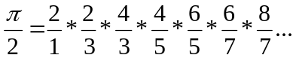

The program should prompt the user for n, the number of terms in the series, compute the product of the n terms, and output the resulting approximation of pi.

- Upload the file to your OAKS account. lab3.py If you left any files on the desktop, remove them. Log off of your computer.

